Exercises:

1. Look for Soviet posters appealing the population to go to the front during World War II. Discuss the content and aesthetics of the posters.
2. Draw a picture or create a collage that would show us the absurdity of war.
3. How would you entitle this photo?
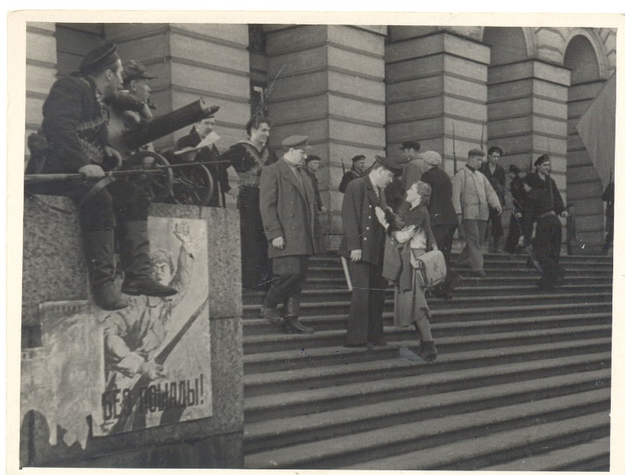

4. “Kuleshov’s Effect” is the combination of two different, unconnected,
independent frames in a way, that it acquires a new meaning. Describe and entitle a
pair of shots according to this example:
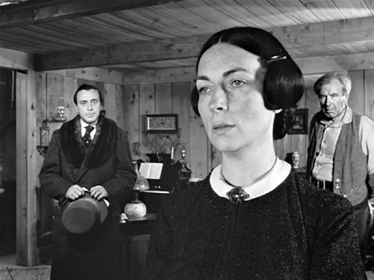
Footage from the movie “Citizen Kane”

5. Discuss the role that art plays in solving global problems, preventing them, and understanding what has already happened? What do you think when art praises political or public leaders? Write an essay (150-200 words).

